Steps to setup webhook

Please install “[GitHub Integration PluginVersion0.5.0](https://plugins.jenkins.io/github-pullrequest)

GitHub Integration Plugin for Jenkins

Is installed

1. Go to Jenkins->Manage Jenkins->system configuration->Configure system [setup github servers]

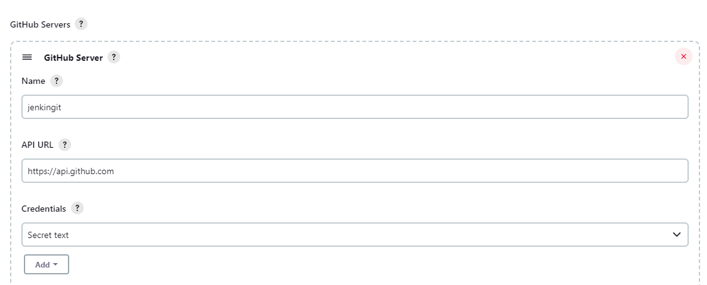

Under credentials

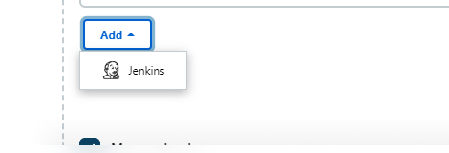

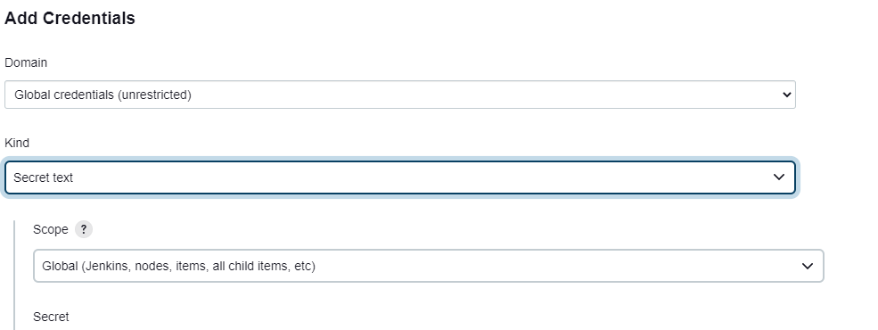

Select secret text

How to get secret text from github [get the token and add it here under secret text)

1. Go to github settings

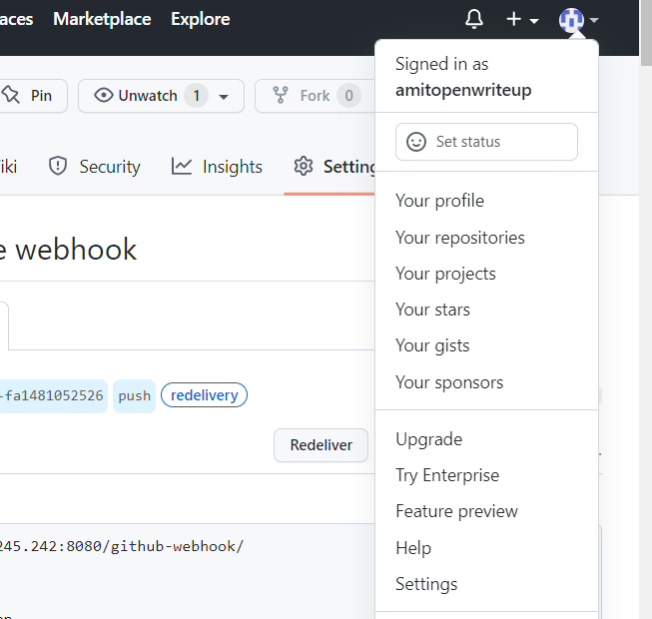

1. Developer setting

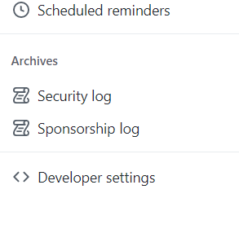

1. Personal access tokens

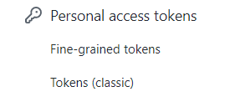

1. Generate new token classic

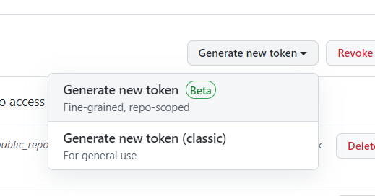

Select repo scope

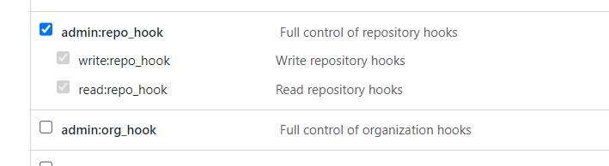

Generate the token

On Jenkins get the token for user

Manage Jenkins->Security->Manage users

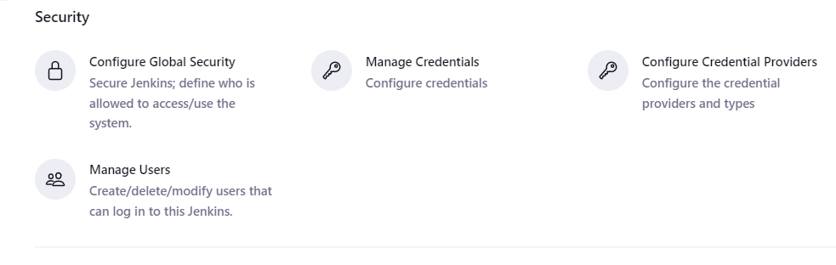

Click on the user(admin) and configure

Get the api token

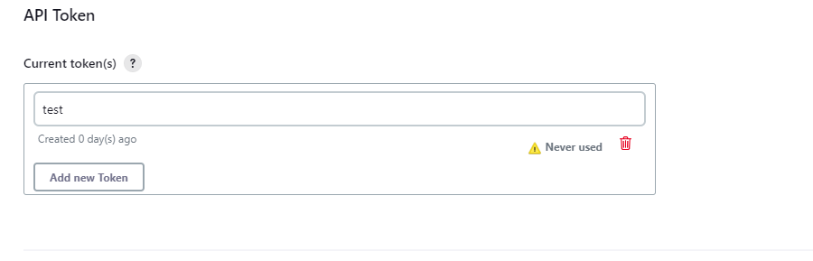

Copy and go to github repo settings

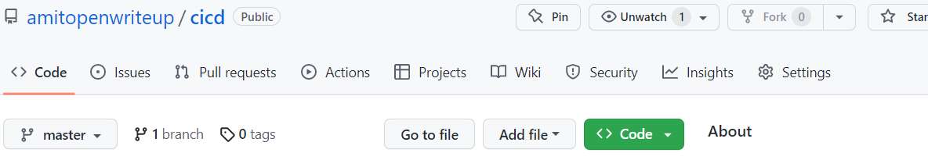

Click on webhook

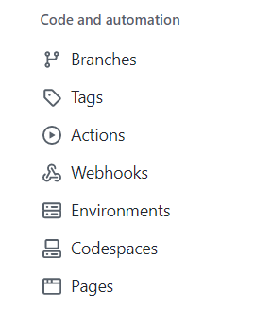

Add the webhook

http:<Jenkins ip>:8080/github-webhook/

provide the api token

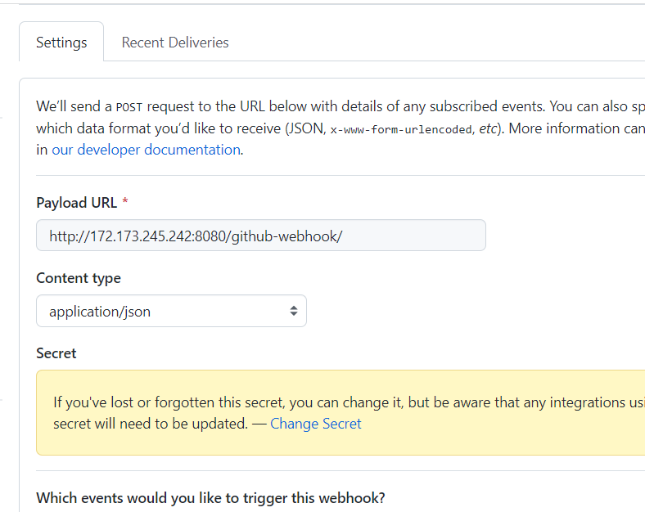



Create a freesytle project

And under scm (git)

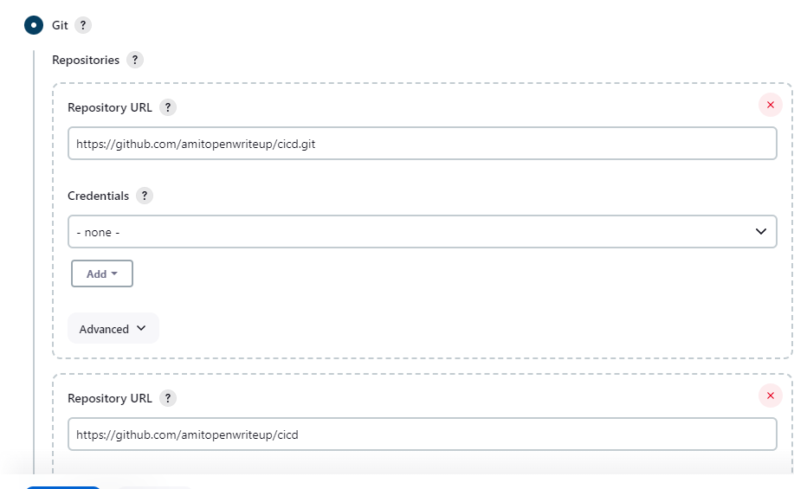

Under build trigger

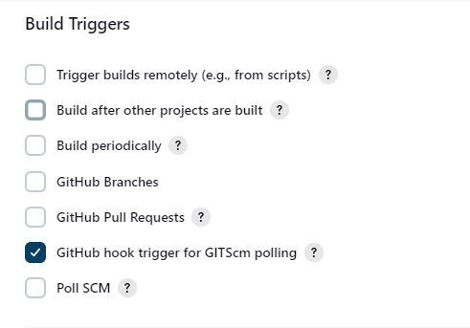

Now clone the repo using git clone command

1. git remote add origin [git@github.com:amitopenwriteup/cicd.git](mailto:git@github.com:amitopenwriteup/cicd.git)
2. touch readme
3. git add readme
4. git commit -m "added"
5. git push -u origin master

check the page it should trigger the build

